**Questions:**

**The Basic HTTP GET/response interaction**

1. Is your browser running HTTP version 1.0, 1.1, or 2? What version of HTTP is the server running?

`

Ans: 1.1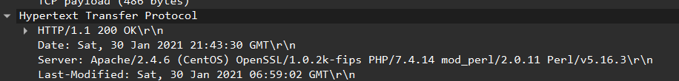

1. What languages (if any) does your browser indicate that it can accept from the server?

Ans:

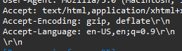

1. What is the IP address of your computer? What is the IP address of the gaia.cs.umass.edu server?

Ans : 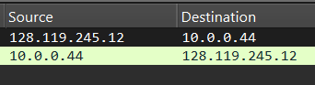

10.0.0.44 128.119.245.12

1. What is the status code returned from the server to your browser?

Ans: 200

1. When was the HTML file that you are retrieving last modified at the server?

Ans: 

1. How many bytes of content are being returned to your browser?

Ans:  128 bytes

1. By inspecting the raw data in the packet content window, do you see any headers within the data that are not displayed in the packet-listing window? If so, name one.

Ans: Yes, there are extra headers in the raw data that are not displayed in the packet-listing window. For example:



**The HTTP CONDITIONAL GET/response interaction**

1. Inspect the contents of the first HTTP GET request from your browser to the server. Do you see an “IF-MODIFIED-SINCE” line in the HTTP GET?

Ans: There is **no** "If-Modified-Since" line….

1. Inspect the contents of the server response. Did the server explicitly return the contents of the file? How can you tell?

Ans: 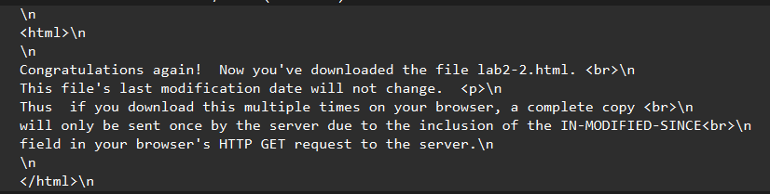

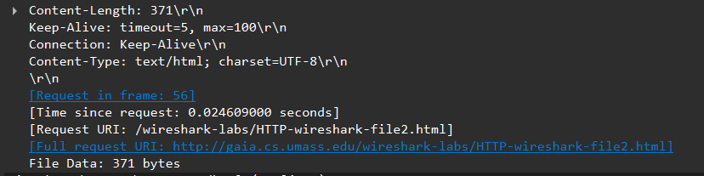

1. Now inspect the contents of the second HTTP GET request from your browser to the server. Do you see an “IF-MODIFIED-SINCE:” line in the HTTP GET6? If so, what information follows the “IF-MODIFIED-SINCE:” header?

Ans : 

1. What is the HTTP status code and phrase returned from the server in response to this second HTTP GET? Did the server explicitly return the contents of the file? Explain.

Ans: 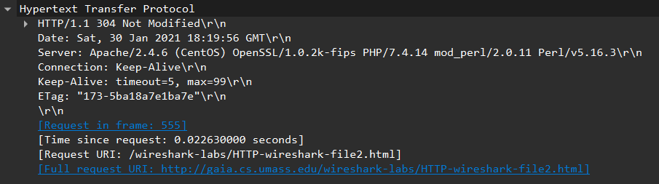

304 Not Modified. The server did **not** return the file contents

**Retrieving Long Documents**

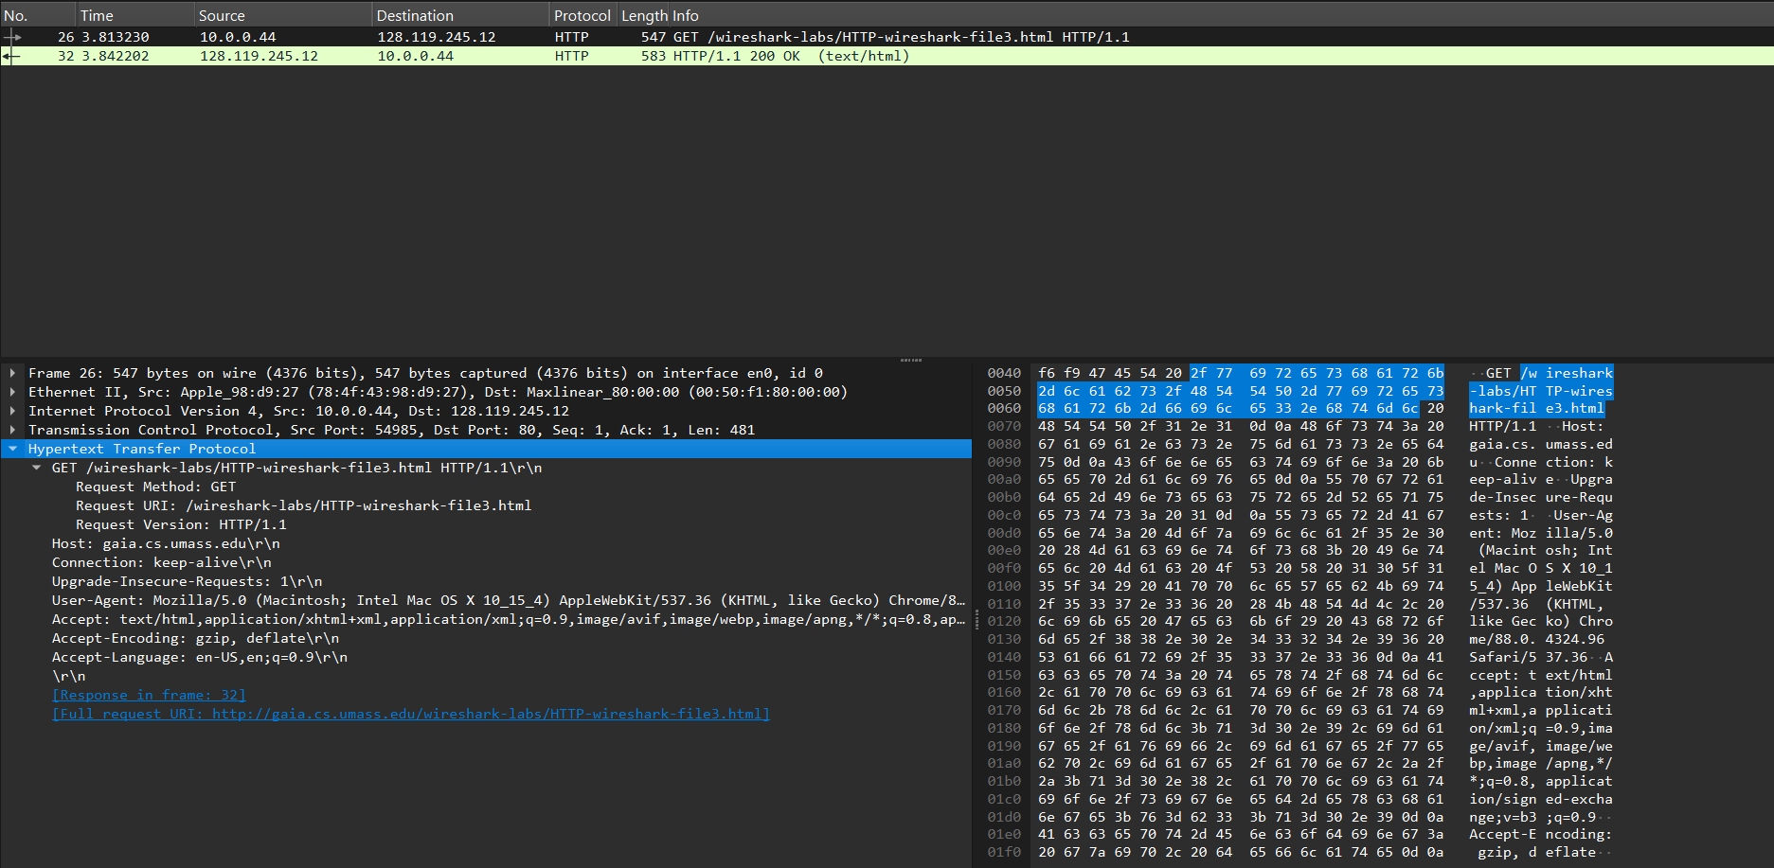

12. How many HTTP GET request messages did your browser send? Which packet number in the trace contains the GET message for the Bill or Rights?

Ans: 1…..26

13. Which packet number in the trace contains the status code and phrase associated with the response to the HTTP GET request?

Ans : 32

14. What is the status code and phrase in the response?

Ans: 200 OK

15. How many data-containing TCP segments were needed to carry the single HTTP response and the text of the Bill of Rights?

Ans: 3(28, 29, 31)

**HTML Documents with Embedded Objects**

16. How many HTTP GET request messages did your browser send? To which Internet addresses were these GET requests sent?

Ans: There are 4 HTTP GET request messages. These requests are sent to the IP address :

1. 178.79.137.164
2. 104.98.115.146
3. 128.119.245.12



17. Can you tell whether your browser downloaded the two images serially, or whether they were downloaded from the two websites in parallel? Explain.

Ans: Serially. As the GET request for the second image (packet 118 at 3.309s) was sent after the 200 OK response for the first image (packet 104 at 3.092s) was received.

**HTTP Authentication:**

18. What is the server’s response (status code and phrase) in response to the initial HTTP GET message from your browser?

Ans: There are two response packets: 482 and 94

The response in packet 482 is:

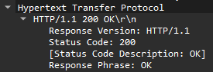

Packet 482

The server responded with status code 200 and phrase OK

The response in packet 94 is:

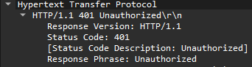

Packet 94

The server responded with status code 401 and phrase “Unauthorized”

19. When your browser sends the HTTP GET message for the second time, what new field is included in the HTTP GET message?

Ans:

